MUHAMMAD-HAMMAD

LAB-TASK 12

QUERY1:

select departments.department_name,first_name from departments left join employees using

(department_id);

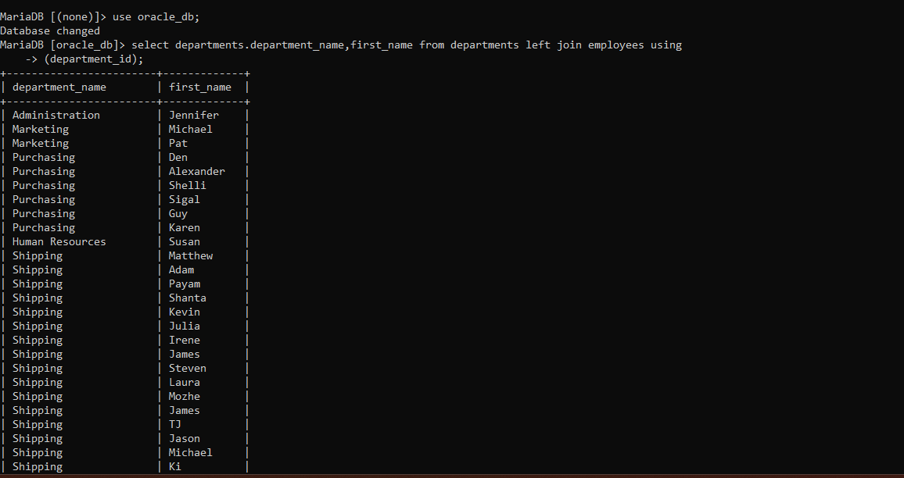

QUERY:2

select first_name,phone_number from employees left join job_history on

employees.employee_id=job_history.employee_id and job_history.start_date is NULL and

job_history.end_date is NULL;

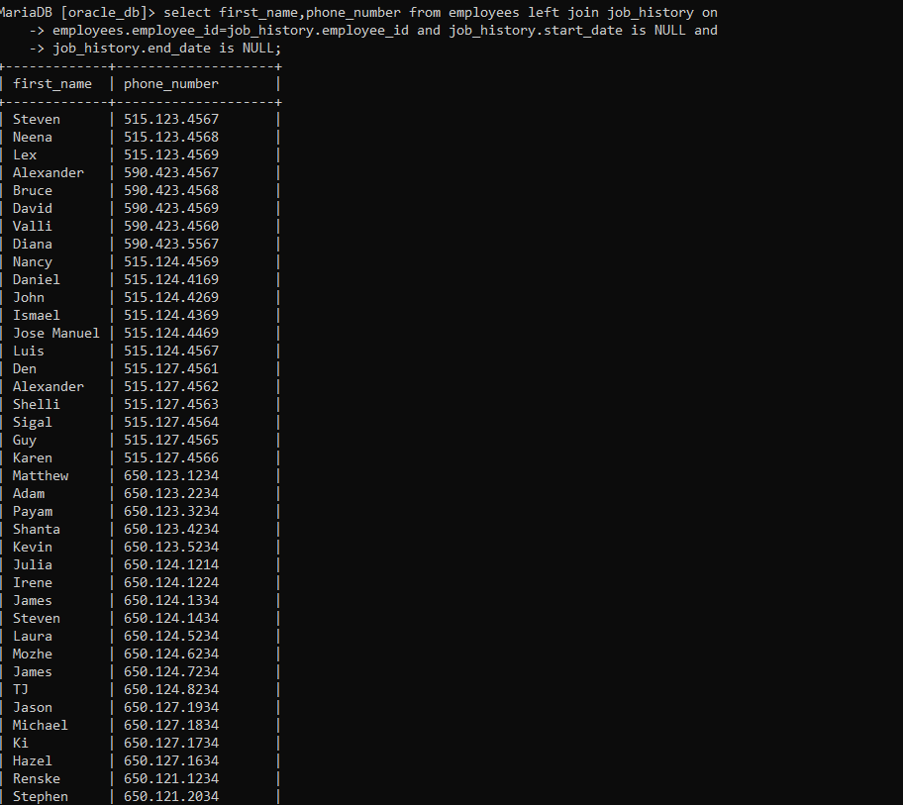

QUERY3:

select region_name, location_id,street_address from locations left join countries on

locations.country_id=countries.country_id right join regions using(region_id);

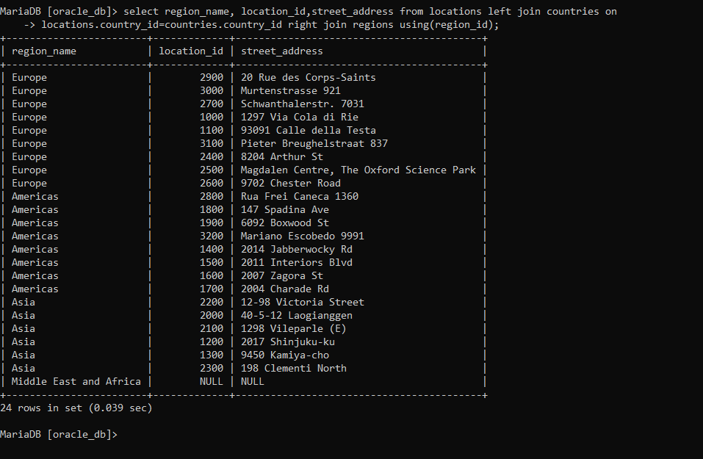

**QUERY4:**

select distinct region_name, location_id from regions left join countries using(region_id) left join

locations on countries.country_id=locations.country_id;

QUERY5:

select distinct Department_name,first_name as Manager_Name from employees right join

departments on employees.employee_id=departments.manager_id;

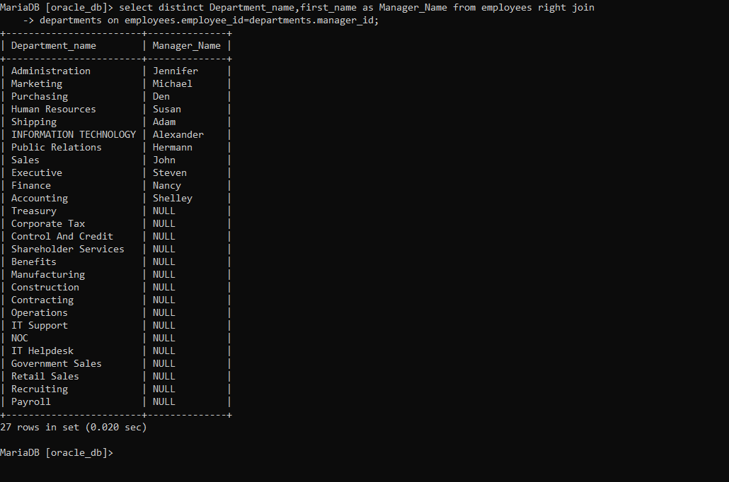

QUERY6:

select distinct locations.location_id from locations left join departments on

locations.location_id!=departments.location_id and department_id is null;

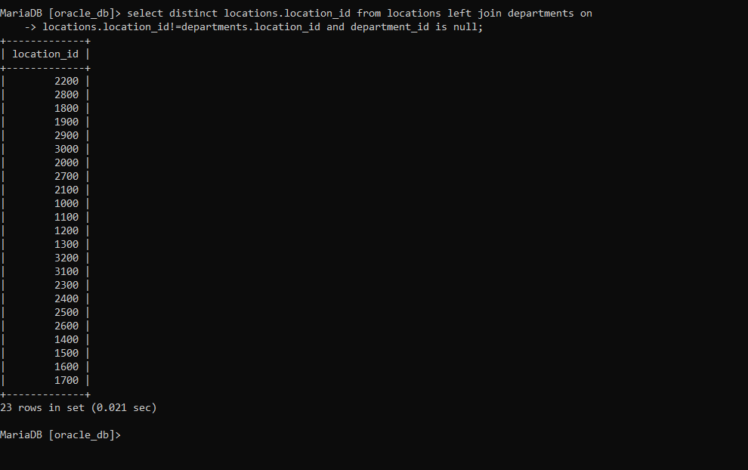

QUERY7:

select count(country_id) as Total_Country from countries left join locations using(country_id) right join

departments on departments.location_id=locations.location_id and department_id is null;

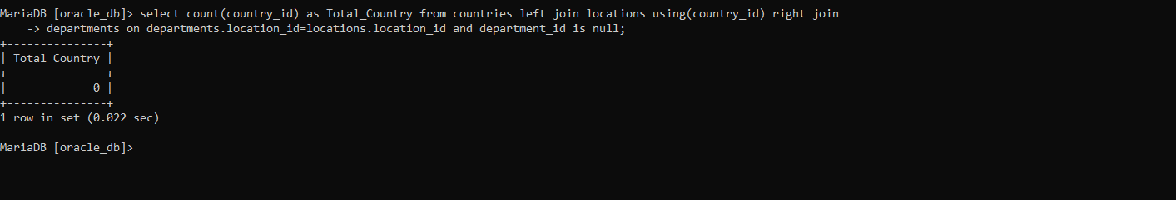

---- UNSEEN TASK----

QUERY 1:

select distinct city,salary from locations left join departments on

departments.location_id=locations.location_id inner join employees on

departments.department_id=employees.department_id and salary is not null and salary>13000;

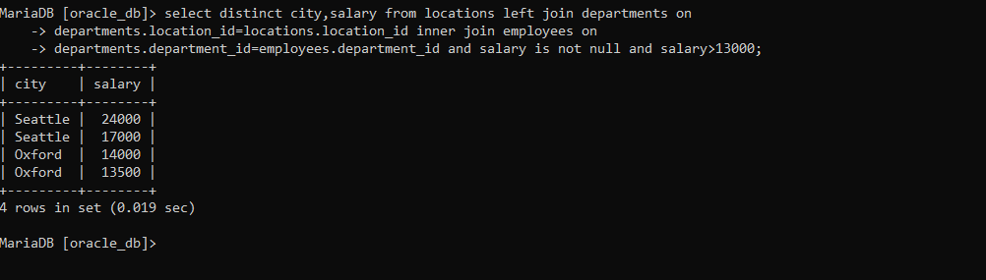

QUERY2:

select first_name as Manager_Name,departments.Manager_id,City,Country_Name from employees

join departments on employees.employee_id=departments.manager_id left join locations

using(location_id) left join countries using(country_id) ;

